CSCI 5010 – Fundamentals of Data Communications

Lab 3

IP Addressing

University of Colorado Boulder

Department of Computer Science

Network Engineering

Professor Levi Perigo, Ph.D.

# Summary

This lab is intended to be an overview of IP addressing, the two formats in which IP addresses can be represented (IPv4 and IPv6) and the difference between public and private IP addresses. This lab will be a baseline for future exploration into these topics used throughout this course.

The questions in the lab are intentionally vague. The purpose of this is for you not only to research, investigate, and learn the technologies, but also become proficient at interpreting both non-technical and technical questions. Being able to research and discover answers on your own will be critical as you progress in your career.

# Note: Feel free to use your laptop or VMs provided for any objective.

# Objective 1: Public and Private IP addresses

1. Using the command prompt, find your laptop’s IP address.
   1. Submit the IP address here (also note how the address was obtained (static/dynamic/etc.) [**1 point**]
2. Navigate to the URL: [www.ipchicken.com](http://www.ipchicken.com). What IP address does it indicate? Is it different from the address above? Why or why not? [**2 points**]
3. Execute a traceroute on your laptop to any URL. Provide a screenshot of the output [**1 point**].
   1. Do all the IP addresses in the trace belong to the same network? What do these IP addresses represent? Is there any additional information you can obtain about these replies that you can gather? [**15 points**]
   2. Which of these are private IP addresses and which of these are public? How did you differentiate, and why would some be public and some private? [**10 points**]
4. What are the IPv6 address that your system obtained? [ **1 point**]
5. Repeat **Obj1.2** using any tool of your choice? What IPv6 address do you see on the public domain? Is it same as the seen above? Why or Why not?? [**10 points**]

# Objective 2: IP Address Format

Note: Prefer using your own laptop instead of the VM, since assigning a static IP to VM might result in losing connection.

1. While connected to the CU campus network, run the command to find your laptop’s IP address from the command prompt again.
   1. How many IP addresses do you come across? Do you see both IPv4 and IPv6 addresses?
   2. Indicate in screenshot [**5 points**]
2. Can you configure an IP address of your choice instead allowing the host to receive an IP address dynamically? If so, include a summary of how you can statically assign an IPv4 address, and provide the screenshot indicating that you have statically configured the IP address [**10 points**]
3. Explain the formatting of IPv4 and IPv6 addresses. [**2 points**]

References:

Windows: [How to Assign a Static IP Address in Windows 10 or Windows 11 (howtogeek.com)](https://www.howtogeek.com/19249/how-to-assign-a-static-ip-address-in-windows/#:~:text=To%20set%20a%20static%20IP%20address%20in%20Windows%2010%20or,IP%20details%2C%20and%20click%20Save.)

Mac: [Use DHCP or a manual IP address on Mac - Apple Support](https://support.apple.com/guide/mac-help/use-dhcp-or-a-manual-ip-address-on-mac-mchlp2718/mac)

Note: At any time if you are having issues, revert to DHCP.

# Objective 3:

Using what you have learned from the in class lectures, and from Objective 1 and Objective 2 of this lab, describe the difference between private and public addresses and the need for ipv6 addressing. [**10 points**]

# Objective 4: IPv4 subnetting

1. What is the difference between classful and classless IPv4 addressing? Why do we need classless addressing and subnetting? [**5 points]**
2. Use the CPT file uploaded on canvas and configure the topology using the subnet 192.168.100.0/24 efficiently. Write down the Interface IPs and subnet details in the space provided on the CPT. [**25 points**]
3. List 2 points to be noted for efficient subnetting? [ **3 points**]

Report Questions:

1. The network graph is shown in Figure. 2.
2. Host H1 sends a packet to the destination 128.96.34.126. Explain how this packet traverses in the network described below. You need to describe who received the packet and what are their reactions. Also trace the return path that is taken. [**2 point**]
3. Host H3 sends a packet to the destination H1 (128.96.34.15). Explain how this packet traverses in the network. [**3 point**]
4. The subnet of H1 has now two different teams and would like to split it into two subnets. Please add one more subnet and add R3 and change the network configurations as you need. Note that you are allowed to modify the network as least disruptive as possible. [**3 point**]

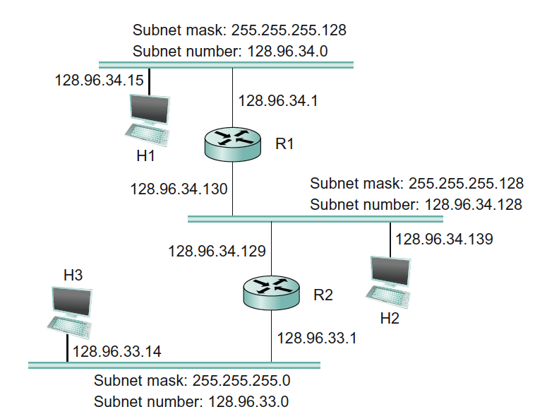

Figure 2.

1. Problem 2

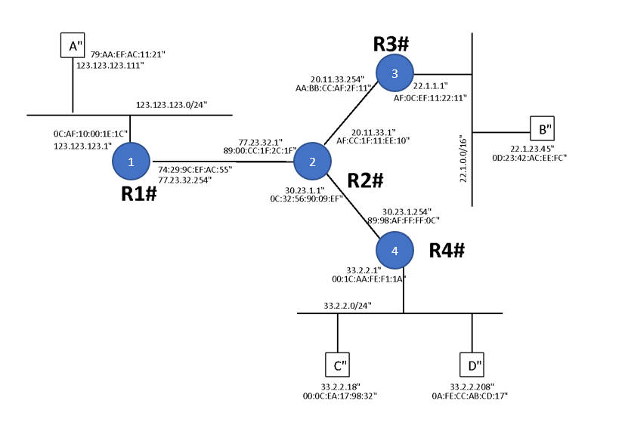

Figure. 3

Above in Figure 3 is the network graph with 4 routers (R1, R2, R3, R4) and 4 hosts (A, B, C, D). Each router interfaces and hosts are labeled with both IP and MAC address, Routing is enabled so that any two hosts can communicate with each other and also the default gateway of each host is set to its gateway router.

1. Suppose that A send an IP packet to B through R1, R2, R3. Write down the IP packet’s content (src MAC, dst MAC, src IP, dst IP) along the path in the Table given below: [**10 points**]

|  |  |  |  |  |
| --- | --- | --- | --- | --- |
|  | src MAC | dst MAC | src IP | dst IP |
| A -> R1 |  |  |  |  |
| R1 -> R2 |  |  |  |  |
| R2 -> R3 |  |  |  |  |
| R3 -> B |  |  |  |  |

Table. 1

1. When C sends out an ARP query for its default gateway, what is the reply to that query? [**2 points**]

# Total Score = ________________/__120__